**Lab 1: Setting up the Web Development Environment**

- Objectives:

- Configure a developer environment (VS Code, browsers, Git) and understand the basic web stack. - Tools/Tech:

- VS Code, Chrome/Firefox, Git/GitHub, Node.js (optional)

- Tasks/Steps:

1. Install VS Code and essential extensions (Live Server, Prettier).

2. Install Git and create a GitHub account/repository for the course.

3. Clone a starter repo and run Live Server.

4. Create a README with project structure and commit changes.

- Deliverables:

- GitHub repo with initial commit, README, and a simple index.html served via Live Server. - Environment installed and verified (4), correct Git workflow & commit history (4), README quality (2). **Solution:**

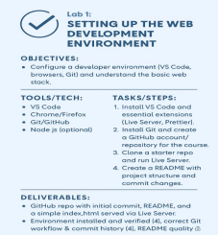

**Complete Installation Steps for Web Development Setup 1. Install a Code Editor**

• Download and install Visual Studio Code

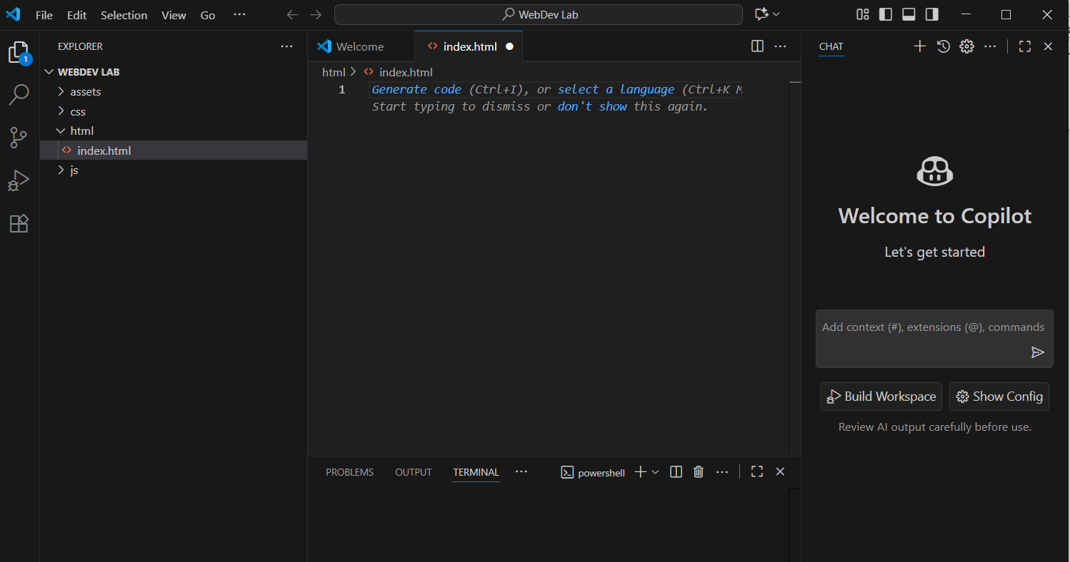

• Optional: Install extensions like Live Server, Prettier, and ESLint

Live Server: ESLint:

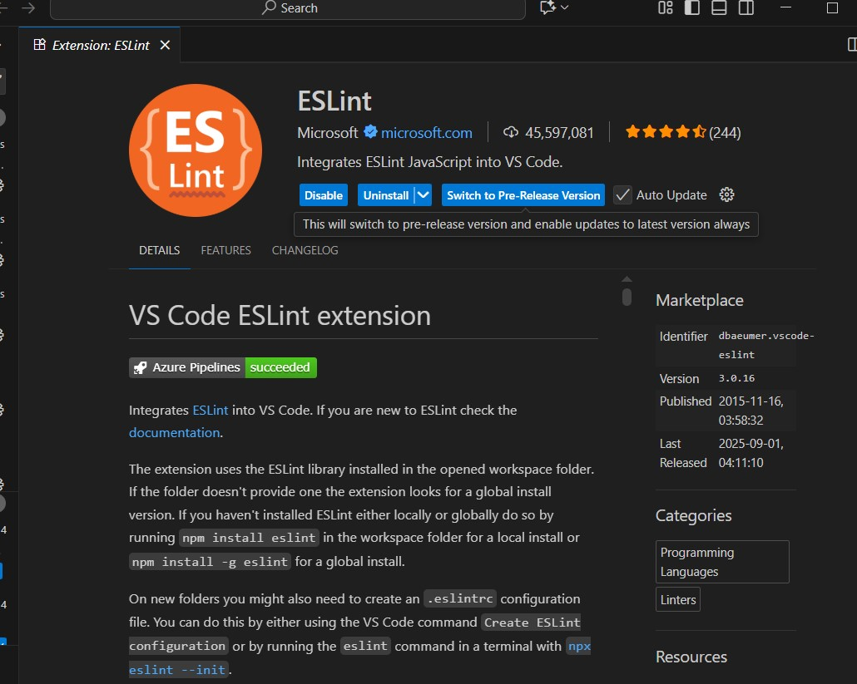

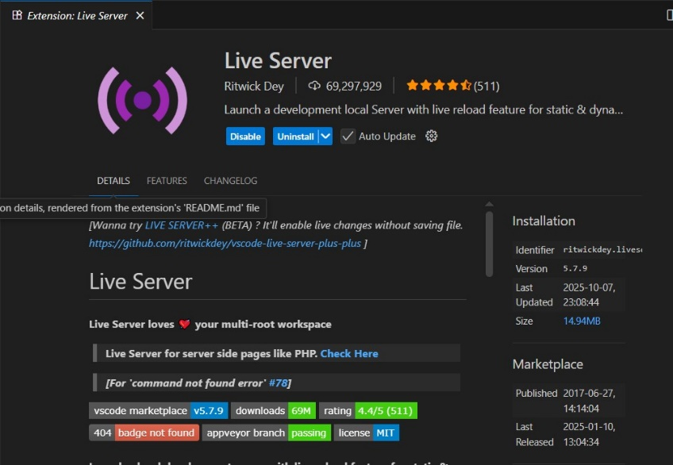

Prettier:

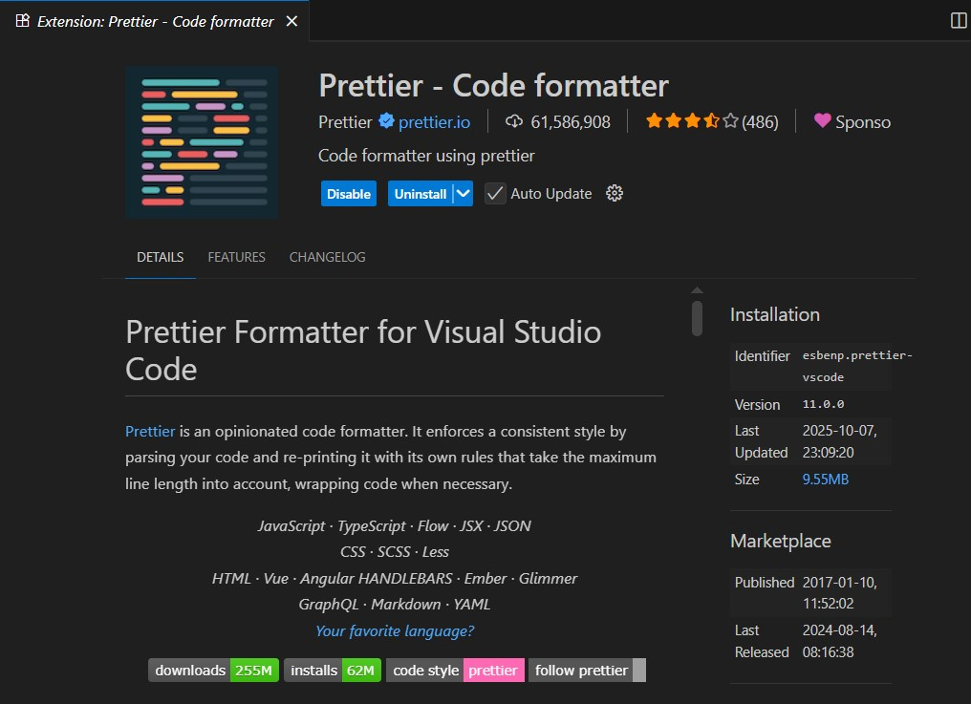

**2. Install Web Browsers**

• Ensure you have the latest versions of **Google Chrome** and **Mozilla Firefox** for testing

Chrome:

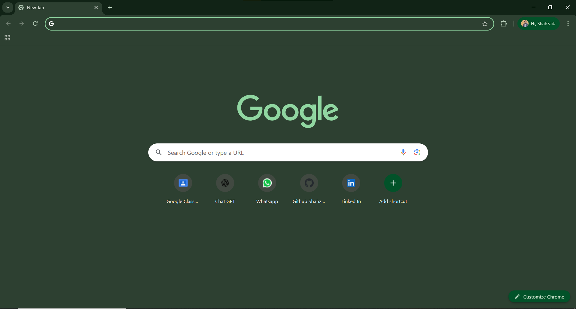

**3. Set Up Version Control**

• Install Git

• Configure Git with your username and email:

• git config --global user.name "Your Name"

• git config --global user.email "you@example.com"

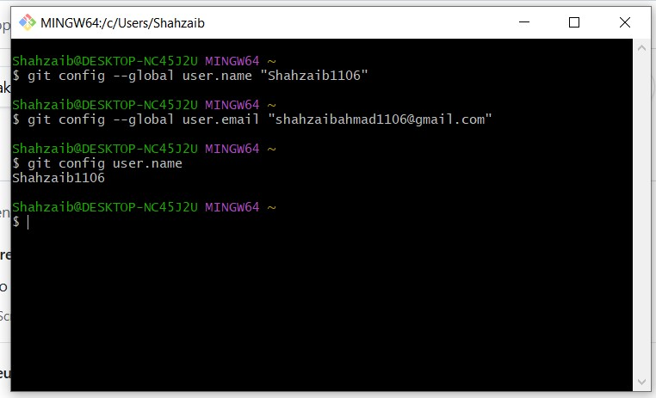

**4. Create a Project Folder**

• Make a folder named WebDevLab1 on your desktop or preferred location • Inside, create subfolders: html, css, js, and assets

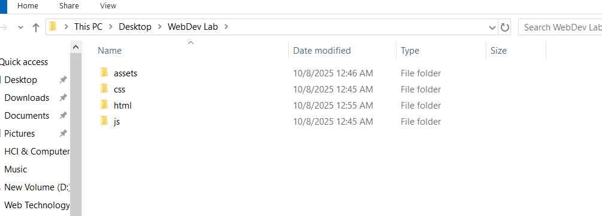

**5. Initialize Git Repository**

• Open the folder in VS Code

• Run:

• git init

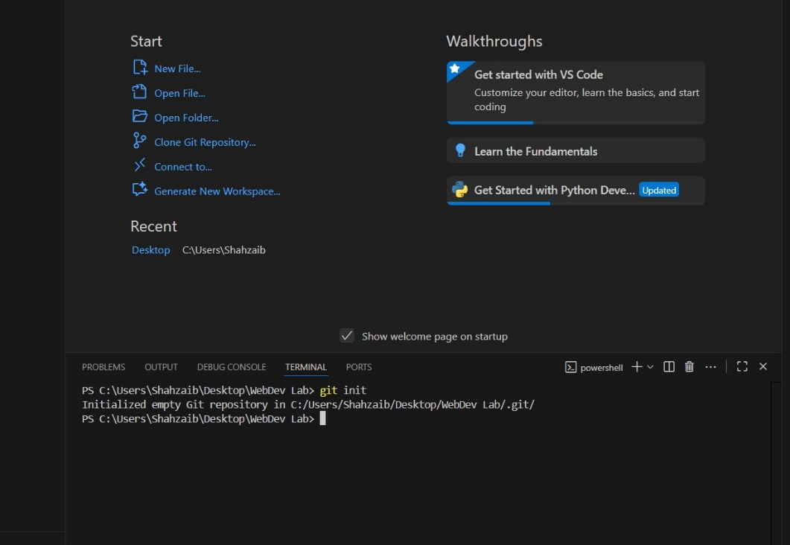

**6. Install Live Server**

• In VS Code, go to Extensions → Search for “Live Server” → Click Install • Right-click your index.html file → “Open with Live Server”

**7. Verify Setup**

• Open index.html and add:

• <!DOCTYPE html>

• <html>

• <head><title>Lab 1</title></head>

• <body><h1>Web Development Setup Complete!</h1></body>

• </html>

• Launch with Live Server to confirm everything works

Code:

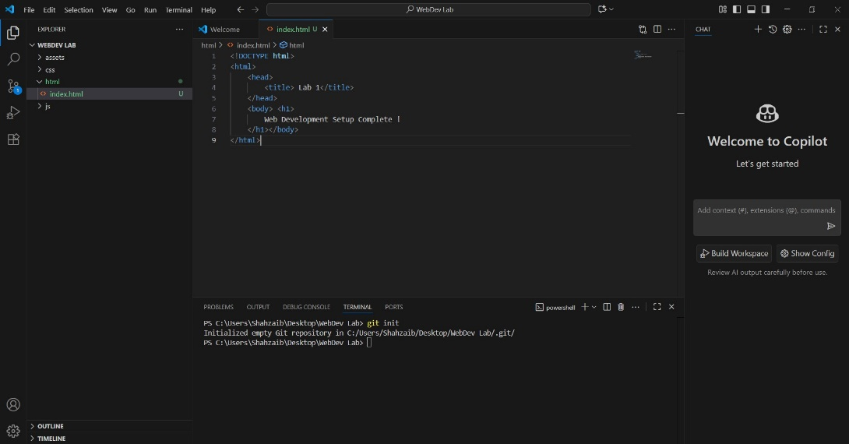

Web Setup :

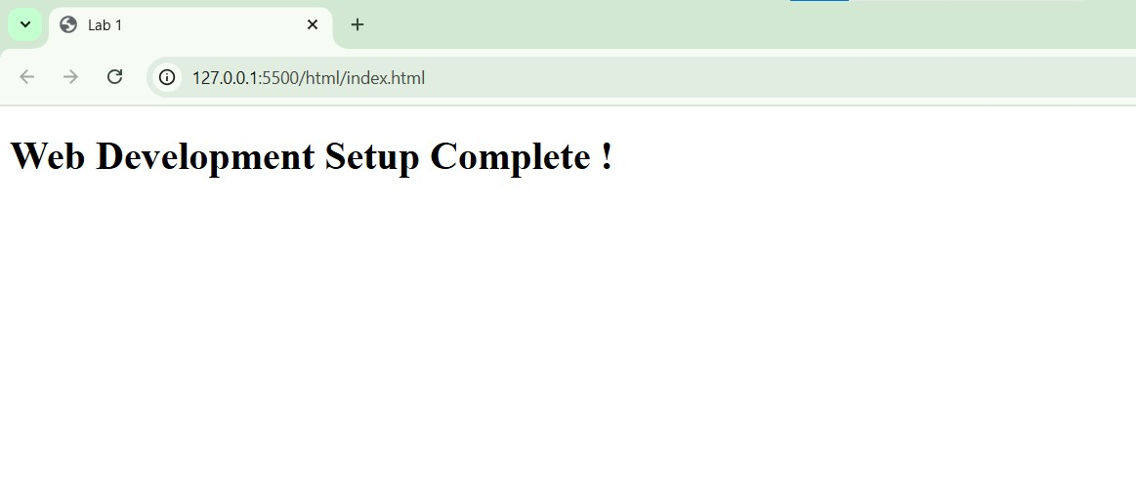

**CONCLUSION:**

____I have downloaded the web development setup, git and extensions and successfully upload my file on GitHub.

**RUBRICS:**

|  |  |  |  |  |  |
| --- | --- | --- | --- | --- | --- |
| **Performance** | | | **Lab Report** | | |
| **Description** | **Total**  **Marks** | **Marks**  **Obtained** | **Description** | **Total**  **Marks** | **Marks**  **Obtained** |
| **Ability to**  **Conduct**  **practical** | 5 |  | **Structure** | 5 |  |
| **Data Analysis &**  **Interpretation** | 5 |  | **Efficiency** | 5 |  |
| **Total Marks obtained** | |  | **Total Marks Obtained** | |  |

Instructor Signature